Sharjah Roads and Transport Authority
Name
Institution Affiliation
Date

Table of Contents
Introduction 3
Background of the Study 3
Problem description: 4
Problem boundaries and impacts: 6
Solution criteria and limitations: 6
Solution Criteria 6
Solution One: Cutting off Electricity in the whole room using a contractor. 6
Solution Two: Cutting of Electricity in the door only. 7
Solution Three: Cutting off the electricity from the door only using a software. 7
Limitation 8
Time- Analysis: 9
Conclusion 10
Reference 11

List of Figures
Figure 1 : Organization Structure of SRTA. 4
Figure 2: Number of vehicles recorded at a given time. 5
Figure 3: Coordinated Traffic Control System. 7
Figure 4: Functionality of the fixed time traffic control. 9
Figure 5: Cross Section of the Control Unit. 10
Figure 6: Functionality of the Dynamic Control System. 10
Figure 7: Human resource required for implementation. 12

List of figures
Table 1b: Time per Branch (In Seconds) 7
Table 2: Street Lighting Without sensor 8
Table 3: Specifications of the problem 8
Table 4: Description of the solution 9
Table 5Time-based plan for researching problem solutions: 9

Introduction
Due to the increasing number of vehicles in Sharjah City, there is need to come up with a solution to the traffic jams witnessed in the City especially during the rush hours. This project comes with an improvement to the already existing traffic light system that do not put into consideration a case where one side of the road is not in use at a particular time. With the sensor traffic system, the vehicles are allowed to cross a lane when not in use just by obtaining a signal that the lane is free.

Background of the Study
Various research undertaken in the transport system in Asian has shown has been an increase in the traffic congestions. In Sharjah, traffic congestion in the City results to about 15% of employees getting late to their places of work as a result of the unending traffic jams in the city. The traffic jams in addition results to excessive wastage of fuels in the jams and pollution of the environment.
Due to these traffic jam related problems and the increasing number of vehicles in the United Arab Emirates and the high rate of growth of population in Sharjah town, there is need to come up with a way of increasing the traffic flows in the major roads in the city especially in the city (PTV AG, 2007).
Sharjah Roads and Transport Authority located in located in Al Aezzrh has responsibilities of planning as well as ensuring a smooth implementation of roads and transport projects in the City. The Authority also has responsibilities of preparing strategic plans and legislation. In addition to these the authority also comes up with the integrated solution to road and marine network systems that is of international standard and ensure that they are safe and according to the various laid down economic development of the country. Every road project in the SRTA system must be environmental friendly and provide a favorable for people (PTV AG, 2007).
Figure 1 : Organization Structure of SRTA.
Director General and Chairman of the Board of Directors
Internal audit
Services of technical support of enterprises
Institutional Support Services
Railway Corporation
Traffic & Roads Est.
Transportation Foundation
Control Room
Sharjah Roads and Transport Authority
Engineer Mohammed Iqbal Mir

Source: (PTV AG, 2007)

Problem description:
As a result of the increasing number of people in Sharjah accompanied by the increasing number of vehicles in the City there is need to use traffic lights to control traffic in the City as this has been seen to be successful in other parts such as in Dubai. The number of traffic in the city is also varying overtime with some hours of the day such as the rush hours witnessing high traffic (PTV AG, 2007). An analysis of the Wasit Street, there has been a record of three peak hours that record high vehicle density. These peak hours are the morning hours from around 6 AM to 9 AM, noon from 12-3PM and 5 to 8 PM as shown in table below. Similar case is therefore most likely to be witnessed in other roads too resulting to the need to come up with street lighting system that is time saving in all the roads in the City. Figure 2: Number of vehicles recorded at a given time.

This flexible street lighting is centered on timed traffic lighting with two colors, Red and green. These lights are used alternatively in different sides of the road meaning the signal is red or green for a specified time for each side of street irrespective of vehicles. In the flexible street light system, vehicles are allowed to cross over to a lane that is not in use at a particular time. A 20 seconds gap is allowed before a signal is given to the other used for the first car to pass hence and therefore need to ensure accurate timing to avoid any collisions.
In a case where there are no vehicles in one side of the road and the others are crowded, there is need of intersection and therefore need for the dominant flows to be adapted to change overtime during the day. This different with the fixed lighting in other places where the driver has to wait for the time to elapse before intercepting. In this system when a vehicle hits the loop it is detected by the detector card which passes an information to the Central Processing Unit (CPU) which checks which among the vehicles comes first and gives an indication of a green light to the first vehicle to pass and a red for the other car. The car given a red signal then stops for 20 seconds waiting for the other car to pass then it will be given a red signal and the sequence continues.

Problem boundaries and impacts:
The sensor traffic light system can only be used in a case where there is power and therefore in a case where there is no sources of power the system cannot function.
Positive impacts
The sensor street light system will make a significant impact in ensuring smooth flow of the traffic and to save time spent on the roads by the road users.
Negative Impacts
The sensor traffic light system may cause car accidents in a case where the system fails giving different signals to the vehicles.

Solution criteria and limitations:

Solution Criteria

Solution One: Coordinated Control.
Here a traffic light controllers are linked to an induction loop that is buried in the ground in the junction that monitors any passing traffic and to the cameras that plays a major role in providing the colors to the controllers that sends signals to the road agency staff through a radio transmitter. The lights and this system is maintained in that they do not show red and green at the same time. This role is played by the Malfunction management system unit (MMU). MMU ensures the controller receives right information from the induction loop (Gibson & David, 2007).
Figure 3: Coordinated Traffic Control System.
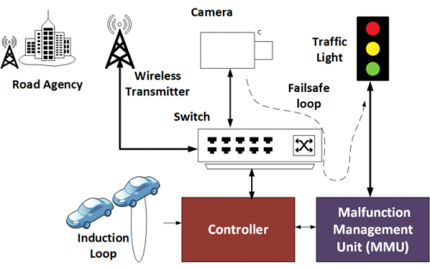
Source (Gibson & David, 2007).
Cost Analysis
Approximately 100, 000 DHS will be required for the labor and for buying the sensor. The maintenance amount require per annum is about 5, 000 DHS
Time Analysis
Three day will be required for this process to be completed. One day will be required for the installation of the induction loop and the sensors, another day for the installation of the cameras and the sensors. The third day will be used for testing of the functionality of the system.
Advantages
This will help in reducing time spent by vehicles on the road.
The system helps in reducing the average waiting time of all traffic categories at intersections hence ensuring punctuality.
Disadvantages
- Security
The system provides room for hacking as the controllers do not verify the message they receive and therefore a message may be sent to by malicious people who want to put the city on a tand still for criminal reasons. The security threat is even worsened by the fact that the messages are not encrypted opening room for analysis by other users.
- Failure
The induction loops may fail causing unnecessary extension of the green signal or the red signals resulting to traffic mess in the roads (Gibson & David, 2007).

Solution Two: Fixed time control
Here electro-mechanical which consists of movable parts (dials, cams together with the shafts) connected to them. They use the dial timer with fixed time plan with gears that determine the intersections time plans. The timer here ranges from 35 seconds to 25 seconds. A failure of one gear is replaced by another gear (Gibson & David, 2007).
Figure 4: Functionality of the fixed time traffic control.
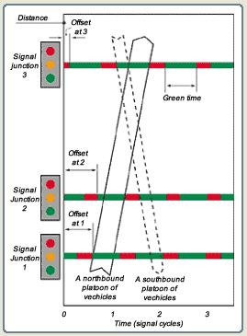
Source (Gibson & David, 2007).
Cost Analysis
This system is cost effective about only 10,000 DHS is required for the following:
- Open room for migration to the new system as adoption of the new system does not require complete rehabilitation of all the existing system and therefore any expansion or replacement does not require abolishment of the whole system. Hardware replacement may be done after a very long time as a lot of changes are done in the software without changing the hardware.
Time Analysis
Three days will be required for this process to be completed. One day for the installation of the computers,
Advantages
Less prone to failure as the failure of one gear is automatically replaced with another gear.
Less costly as it is not computerized.
Disadvantages
This process does not respond dynamically as they use predetermined time system and therefore it does not respond effectively to changes in traffic patterns overtime.
Cannot be used where the vehicle flows changes overtime.

Solution Three: Dynamic Control.
Dynamic control detector uses an input from detector. Detectors under this control system uses a sensor to detect presence of a vehicle or a pedestrian. When the detector detects a presence of car it the inductance of the coil decreases sending a signal to the control unit to control the switching of traffic light. This system can give more time for intersection in a heavy traffic or even shorten it in a case where the traffic is flowing. This system can also skip a face that has no or little traffic. It can be put built inside the pavement, non-motorized for pedestrians (Gibson &David, 2007).

Figure 5: Cross Section of the Control Unit.
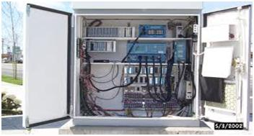
Source (Gibson & David, 2007).
Figure 6: Functionality of the Dynamic Control System.
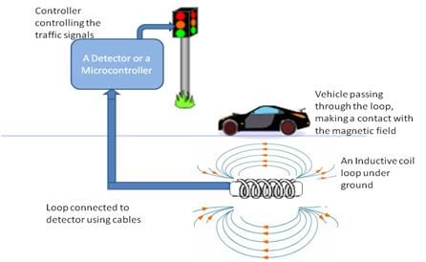
Source: (Gibson & David, 2007).
Cost Analysis
Requires about 20,000 DHS to purchase the Induction loop and the controllers. Another 5,000DHS will be required for labor. The system will also require 1,000 DHS for annual maintenances.
Time Analysis
Requires about 2 months for an installation process to be complete. This will include the installation of the induction loop that will take 2 weeks, the control system that will take another 2 week as well one month testing period.
Advantages
Requires less time to implement.
Reduces collision of vehicles as the controller only changes color after the vehicle has passed.
Reduces waiting time for both vehicles and pedestrians as it allows for the intersection of the vehicles.
Reduces Driver Frustration.
Disadvantages
Requires stable power supply for the controller to function.
Detectors may fail giving different signals which may result to traffic mess.
Selected Solution
Dynamic Control System.
The selected solution will be to work with the Dynamic model as it is less costly and can be used when the traffic is heavy in one face and when there is no traffic it will therefore be appropriate for use by Sharjah Roads Authority since Sharjah witnesses different Capacity of traffic at different times.
Dynamic model also requires less time to implement and since the project only had 2 months for implement Dynamic System will the more appropriate system for the City.
Dynamic System is also cost effective in terms of maintenance and installation.

Table 2: Specifications of the problem.
Specifications | Discretion
User friendliness | It is easy to understand and maintain
Cost | Allocated budget of 1.2 Million DHS
Level of Accuracy | High level of accuracy as the system will be monitored by the traffic control team.
Reliability of the System | Is less prone to failure.
Time to be taken | Should take a period not more than 2 months to implement.

Table 3: Description of the solution

Figure 7: Human resource required for implementation.
For the project to be implemented the following personnel will be required:
Source: (Gibson & David, 2007).
The software engineer are responsible for coming up with the system, database managers for management of the system maintenance team who will ensure the system is always functional.

Time- Analysis:
After preparation of this proposal the next step will be to carry out a research for problem solution. The project is approximated to take approximately 6 weeks to be completed; it will be commencing on 1st November 2017 to 6th December 2017. The table below gives a summary of the activities involved in the coming up with the problem solution and the allocated time period.
Table 5: Time-based plan for researching problem solutions:

ID | Brief description | Duration (Days) | Start Date | Finish | predecessor | Name of student
A | Formulation of strategies for the research. | 1 | 1st Nov | 1st Nov | -
B | Setting up of equipment required for the research | 2 | 3rd Nov | 5th Nov | A
C | Literatures survey | 4 | 6th Nov | 9th Nov | B
D | Drafting of methodology | 3 | 10th Nov | 12th Nov | C
E | Collection of data. | 5 | 13th Nov | 17th Nov | D
F | Data analysis | 6 | 18th Nov | 23^{trd} Nov | E
G | Discussion of the findings & selection of implementation procedure | 7 | 24th Nov | 30th Dec | F
H | Implementation | 6 | 1st Dec | 6th Dec | G

Conclusion
By adopting the dynamic traffic control system will help in reducing traffic jams in the City of Sharjah by allowing drivers to cross over to the lanes that are not in use at a particular time. The system will work by giving signals to drivers on an empty lane so that it can cross over. Though the system will help in reducing traffic jams it maybe more costly to implement and also the maintenance cost may be high. Of all the analyzed control systems the system was the most appropriate as it is the most cost effective and requires less time for implementation.

Reference
Africon Ltd. Dubai (2006). Derivation of Updated 5-Year Transportation System Implementation Plans for Dubai, 14.
Gibson, David (2007), “A new look at sensors FHWA’s updated traffic Detector Handbook describes in-roadway and over roadway technologies for vehicle detectors as key ITS deployment”
Sharjah overhauls transport services. (2015, September 29). (sharjahupdate) Retrieved from http://www.sharjahupdate.com/2015/09/sharjah-overhauls-transport-services/
PTV AG (2007). Sub-Report “Bus Network Planning”, Appendix C – Present Network Analysis. Dubai Public Transport Bus Master Plan.

